AIML SESSION 02 ASSIGNMENT SUBMISSION

Name of student: Vaibhav Vijay Kate
Domain/subject name: AIML (Artificial Intelligence & Machine Learning)
College and Branch name: Government Polytechnic College Washim (IF)

Task 1: if Statement
Program Code:
# Q1.py - Check voting eligibility
# Take age as input from user
age = int(input("Enter your age: "))
# Check if user is eligible to vote
if age >= 18:
print("You are eligible to vote.")

OUTPUT Screenshot:
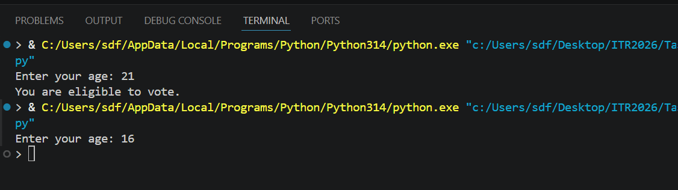
Task 2: if-else Statement
Program Code:
# Q2.py - Check even or odd number
# Take number as input
num = int(input("Enter a number: "))
# Check if number is divisible by 2
if num % 2 == 0:
print("Even Number")
else:
print("Odd Number")

OUTPUT Screenshot:
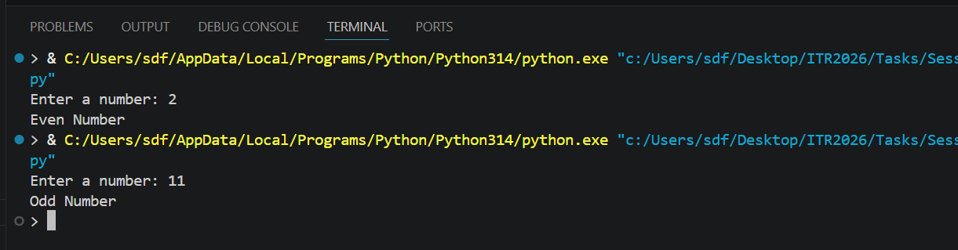
Task 3: if-elif-else Statement
Program Code:
# Q3.py - Grade calculator based on marks
# Take student marks as input
marks = int(input("Enter your marks: "))
# Check marks against grading scale
if marks >= 90:
print("Grade A - Excellent")
elif marks >= 75:
print("Grade B - Good")
elif marks >= 60:
print("Grade C - Average")
elif marks >= 40:
print("Grade D - Pass")
else:
print("Fail")

OUTPUT Screenshot:
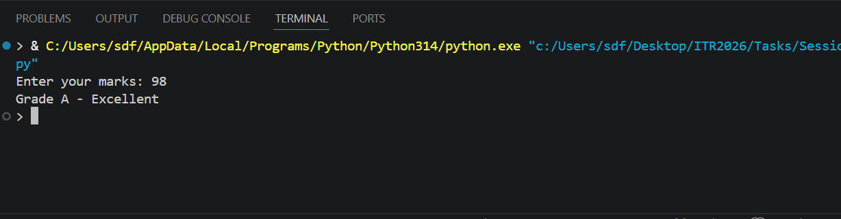
Task 4: For Loop with range()
Program Code:
# Q4.py - For loop using range functions
# range(1, 31) generates values from 1 to 30
print("Numbers from 1 to 30:")
for i in range(1, 31):
print(i)
print("------------------")
# range(1, 51, 2) starts at 1, goes up to 50, increments by 2
print("Odd numbers from 1 to 50:")
for i in range(1, 51, 2):
print(i)
print("------------------")
# Calculating sum of numbers from 1 to 15
total = 0
for i in range(1, 16):
total += i
print("Sum =", total)

OUTPUT Screenshot:
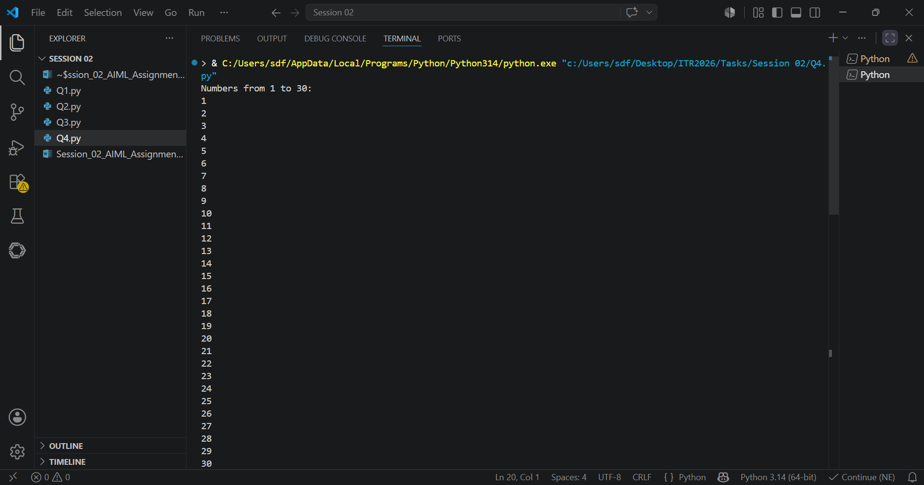
Task 5: While Loop
Program Code:
# Q5.py - Print numbers and cubes using while loop
num = 1
# Loop runs while num is 20 or less
while num <= 20:
print("Number =", num, "Cube =", num ** 3)
num += 1

OUTPUT Screenshot:
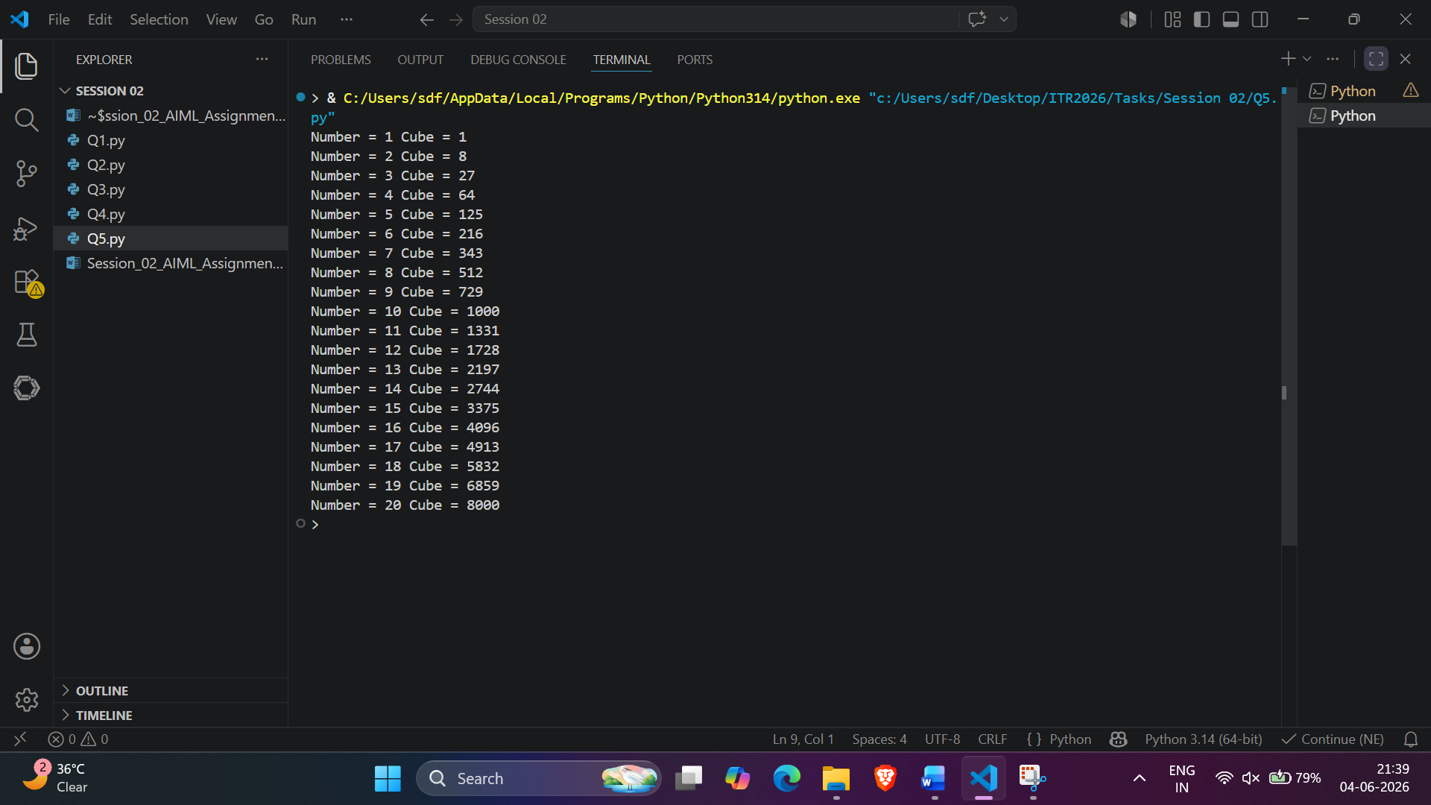
Task 6: While Loop - User Controlled
Program Code:
# Q6.py - Keep adding positive numbers until zero or negative is entered
total = 0.0
# Repeatedly take input until non-positive number is entered
while True:
num = float(input("Enter a positive number: "))
if num <= 0:
break
total += num
print("Total Sum =", total)

OUTPUT Screenshot:
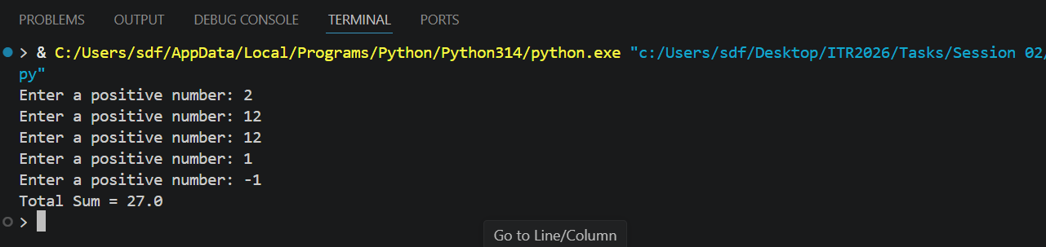
Task 7: Nested if Statement
Program Code:
# Q7.py - Weather advice using nested if statements
temperature = int(input("Enter temperature: "))
is_raining = input("Is it raining? (yes/no): ")
# Nested logic for weather advice
if temperature > 30:
if is_raining.lower() == "yes":
print("Hot and rainy, carry umbrella.")
else:
print("Hot day, wear light clothes.")
elif temperature < 15:
if is_raining.lower() == "yes":
print("Cold and rainy, wear jacket and take umbrella.")
else:
print("Cold day, wear warm clothes.")
else:
print("Weather is pleasant. Dress comfortably.")

OUTPUT Screenshot:
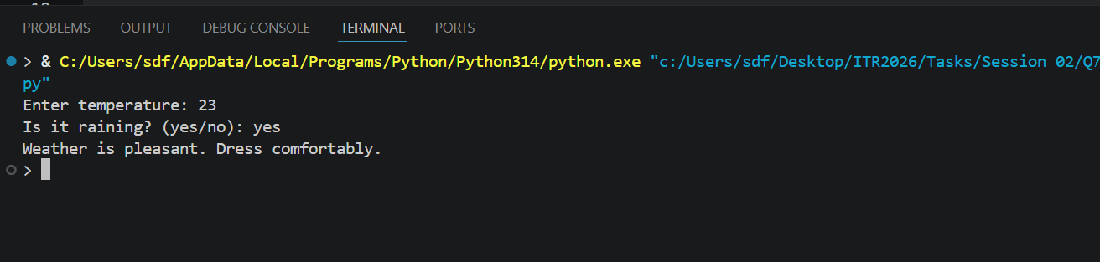
Task 8: For Loop + if-elif-else
Program Code:
# Q8.py - FizzBuzz from 1 to 40
# Loop through numbers 1 to 40
for num in range(1, 41):
if num % 3 == 0 and num % 5 == 0:
print("FizzBuzz")
elif num % 3 == 0:
print("Fizz")
elif num % 5 == 0:
print("Buzz")
else:
print(num)

OUTPUT Screenshot:
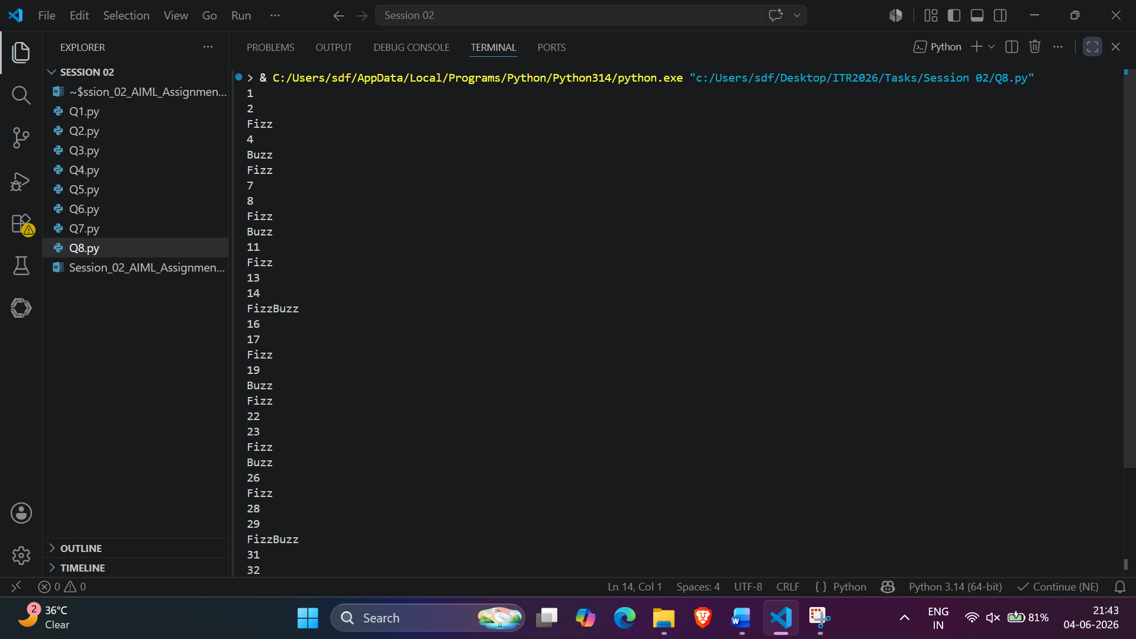
Task 9: Menu Driven Program
Program Code:
# Q9.py - Menu driven calculator
while True:
print("\nCalculator Menu")
print("1. Add two numbers")
print("2. Subtract two numbers")
print("3. Multiply two numbers")
print("4. Divide two numbers")
print("5. Exit")
choice = int(input("Enter your choice: "))
if choice == 5:
print("Exiting Calculator...")
break
num1 = float(input("Enter first number: "))
num2 = float(input("Enter second number: "))
if choice == 1:
print("Result =", num1 + num2)
elif choice == 2:
print("Result =", num1 - num2)
elif choice == 3:
print("Result =", num1 * num2)
elif choice == 4:
if num2 == 0:
print("Error! Division by zero is not allowed.")
else:
print("Result =", num1 / num2)
else:
print("Invalid Choice")

OUTPUT Screenshot:
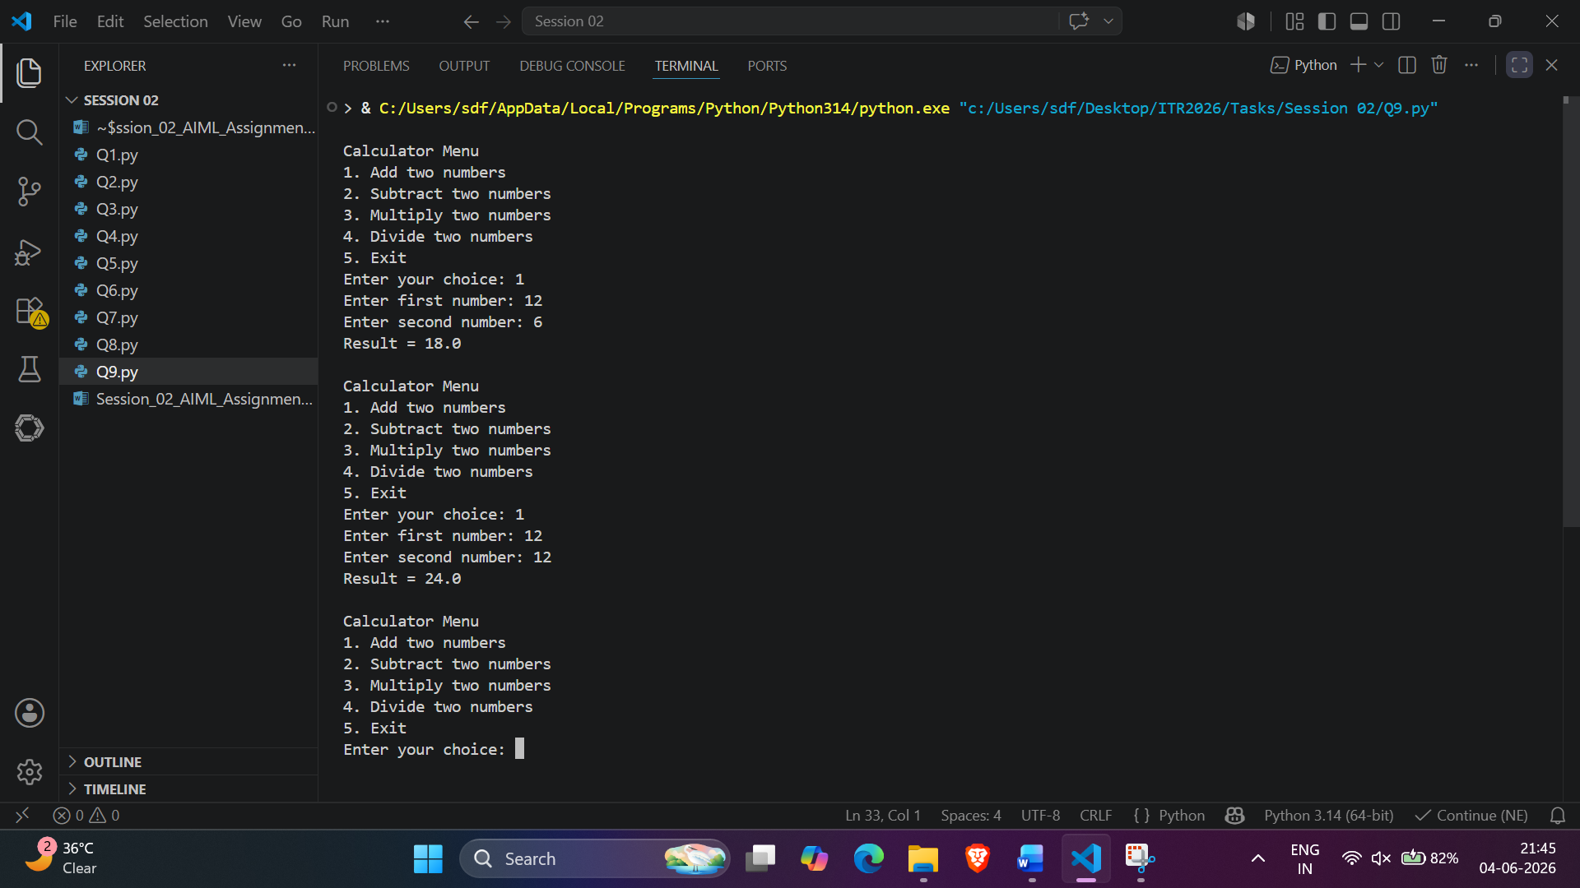

Task 10: Debugging
Program Code:
# Q10.py - Debugged python code with fixes
# Convert input to integer because input() returns a string
num = int(input("Enter a number: "))
# Added missing colons (:) to if-elif-else statements
if num > 100:
print("Large number")
elif num > 50:
print("Medium number")
else:
print("Small number")
count = 1
# Added missing colon (:) to while statement
while count < 10:
print(count)
# Corrected count increment syntax
count += 1

OUTPUT Screenshot:
